|  |  |
| --- | --- |
| Roll No. A027 | Name: Shubham Patil |
| Program: B-Tech (CSBS) | Division: |
| Batch: B2 | Date of Experiment: 19/09/2020 |
| Date of Submission: | Grade: |

**Practical 9**

**(PART – A)**

***Aim: To convert CFG to PDA***

**Outcome:** After successfully competing of this practical, students will be able to learn:

* What is PDA, CFG?
* Converting context free grammar to PDA

**A.1 Reading**

Read Page 98 to 106

**A.2 Tasks**

1. Develop a PDA (LL) for the following grammar

S -> (S)S | €

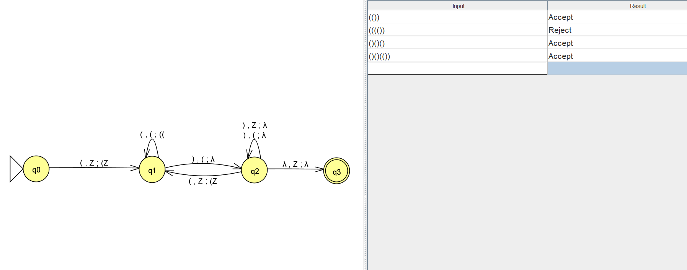

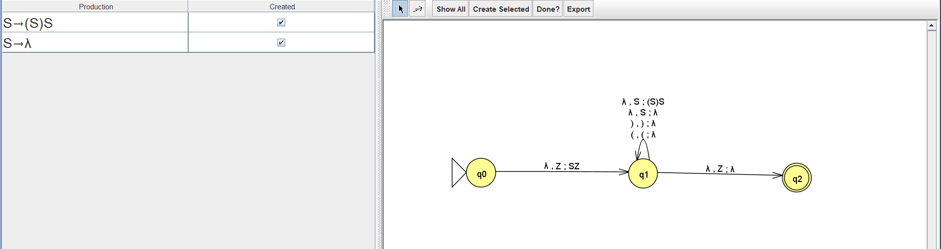

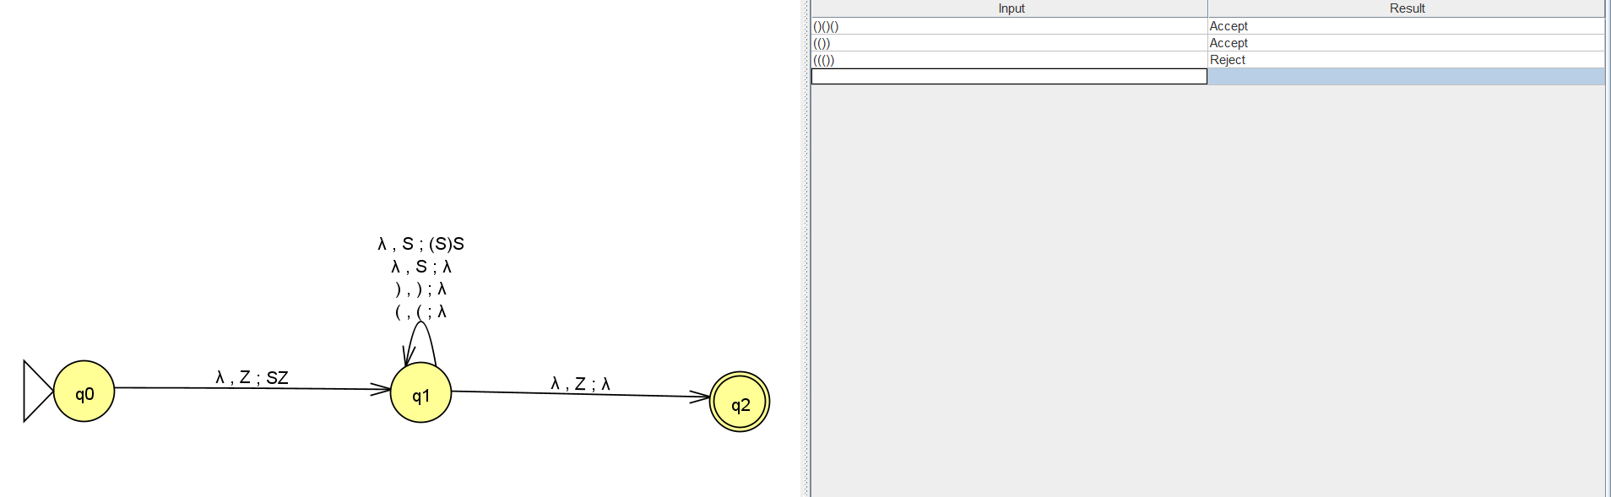

1. Develop a PDA (LR) for the following grammar

S -> aSa | bSb | X

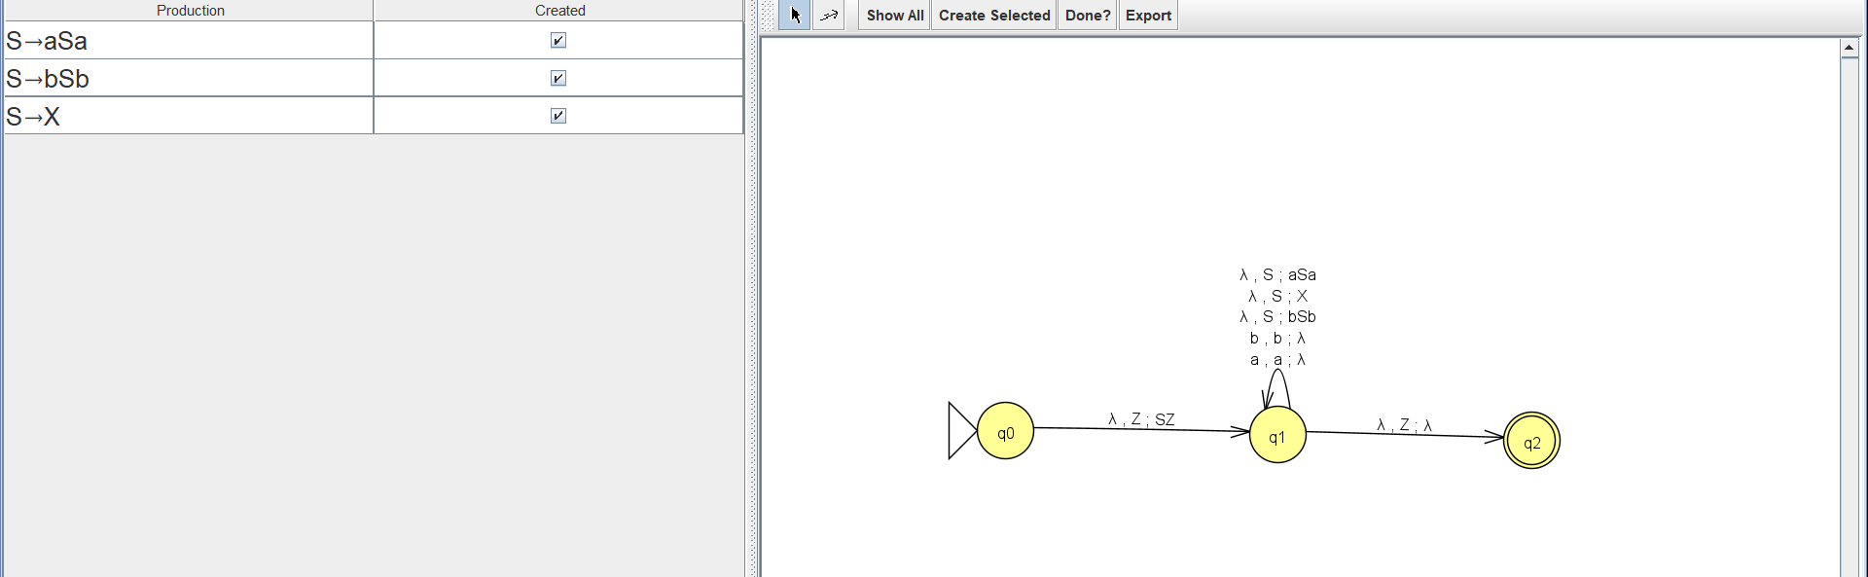

**PART B**

(PART B: TO BE COMPLETED BY STUDENTS)

**(Students must submit the soft copy as per following segments within two hours of the practical. The soft copy must be uploaded on the Portal or emailed to the concerned lab in charge faculties at the end of the practical in case the there is no portal access available)**

|  |  |
| --- | --- |
| Roll No. A027 | Name: Shubham Patil |
| Program: B-Tech (CSBS) | Division: |
| Batch: B2 | Date of Experiment: 19/09/2020 |
| Date of Submission: | Grade: |

**B.1 Output:**

1. Write a procedure to generate the PDA from CFG using JFLAP tool.

1. Open JFLAP tool.
2. Click on grammar.
3. Enter the grammar that you want to convert to PDA.
4. Click on convert and then click on convert CFG to PDA (LL).
5. Click on show all.

**B.2 Observations/Learning**

We were able to create PDAs for the given grammars.

**B.3 Conclusion:**

The PDA for the given grammar accepts the well formed parentheses.

***B.4 Curiosity Question***

***Can you generate a general formula to find total number of states when positions of particular input is fixed from left hand side? Explain***